Updating Non AMS Route Data

- New link as of 5/22/2020. https://workforce.usps.gov/
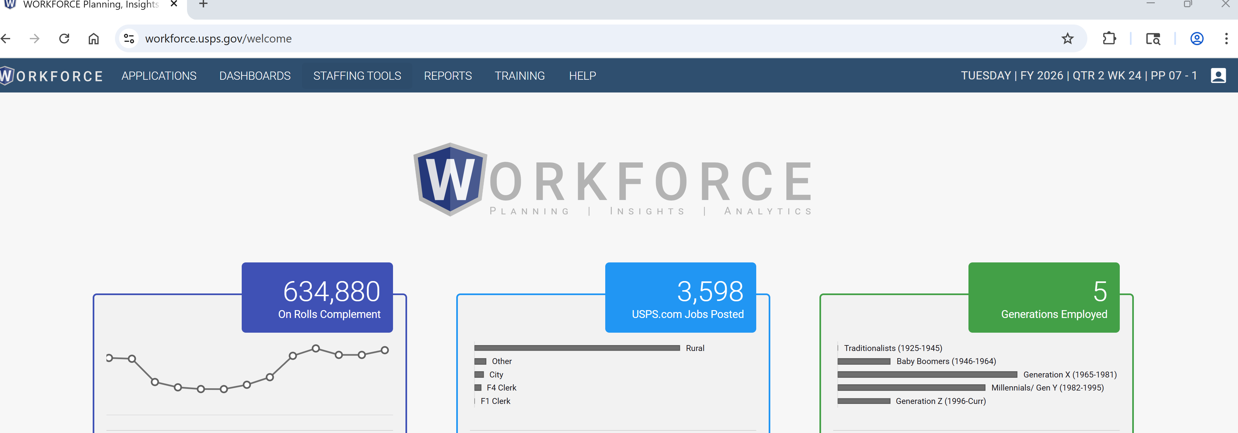
- Login using your credentials: Automically login in looking at your ACE ID
- Go to Dashboards tab
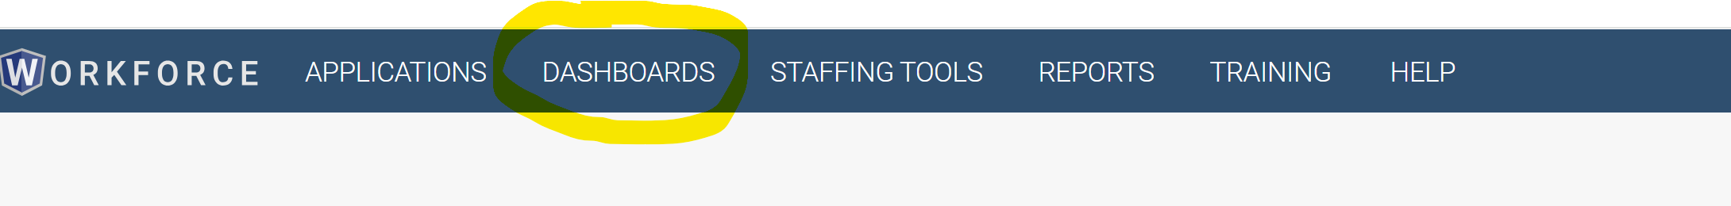
- Go to F2|City Delivery option
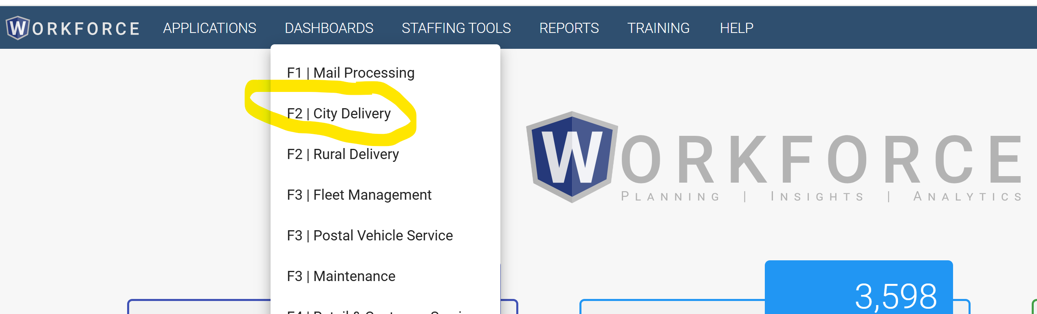
- Go to Filter option near upper left
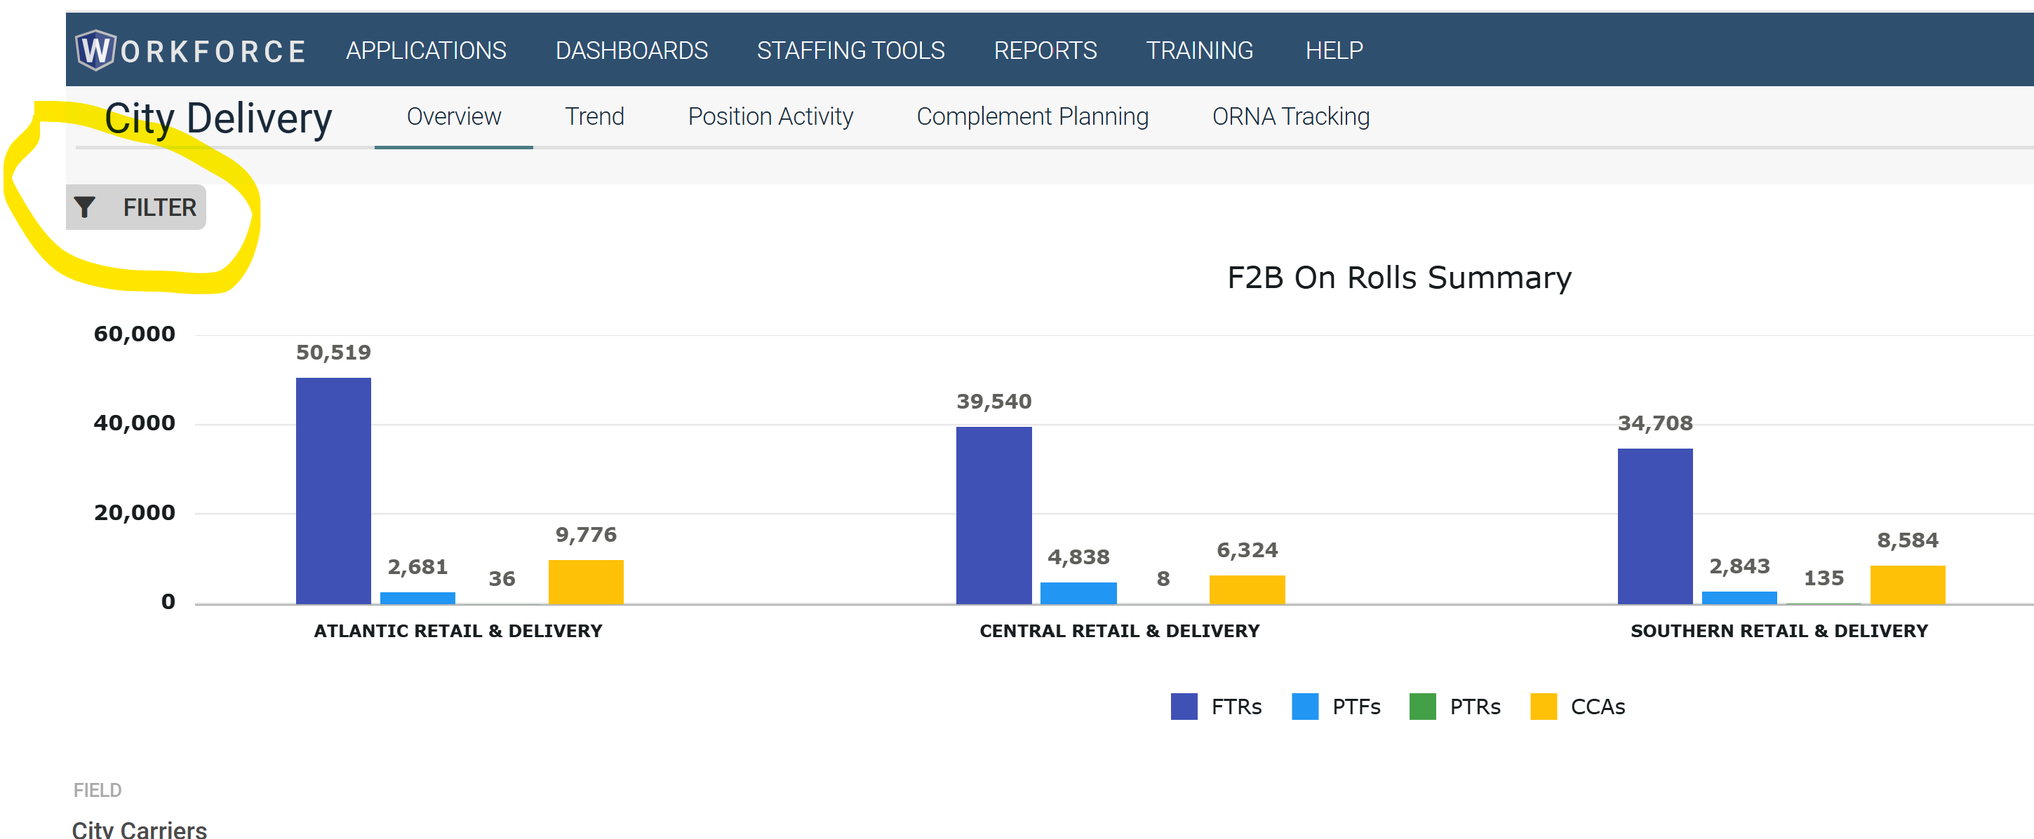
- Click Finance radio button under Ranking Level and wait for it to load
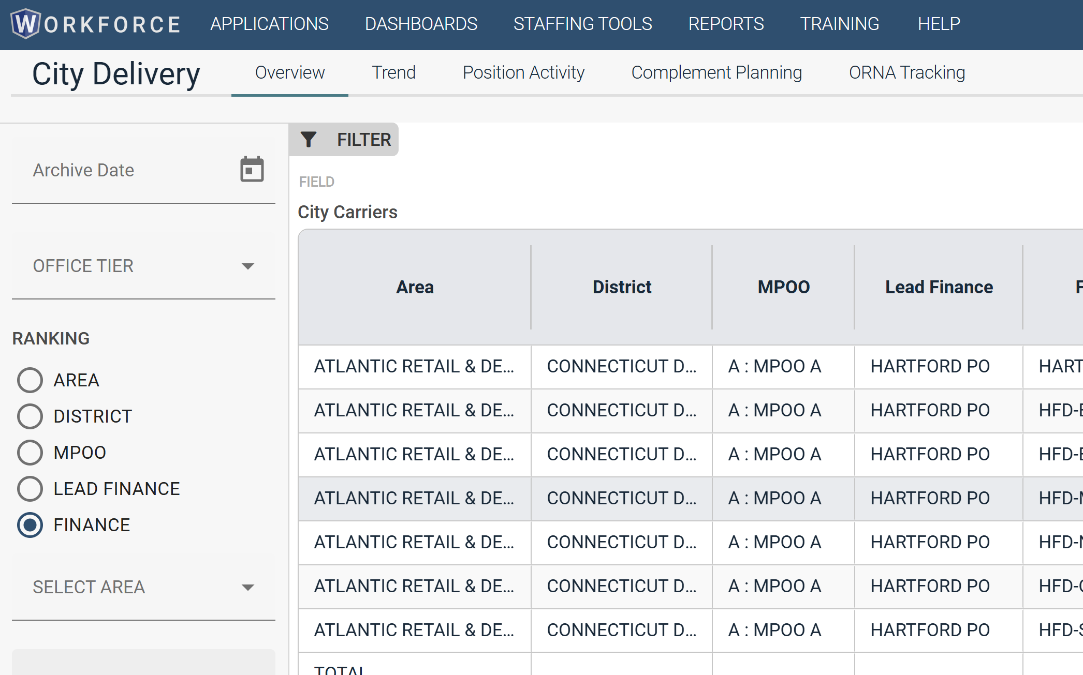
- Click the Export button (down arrow) at the top of the grid, far right
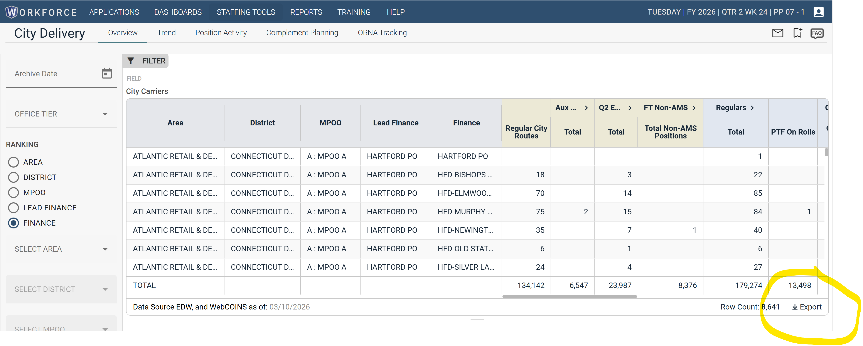
- It will take longer than expected to run and give you an option to download, (20-30 sec or more).
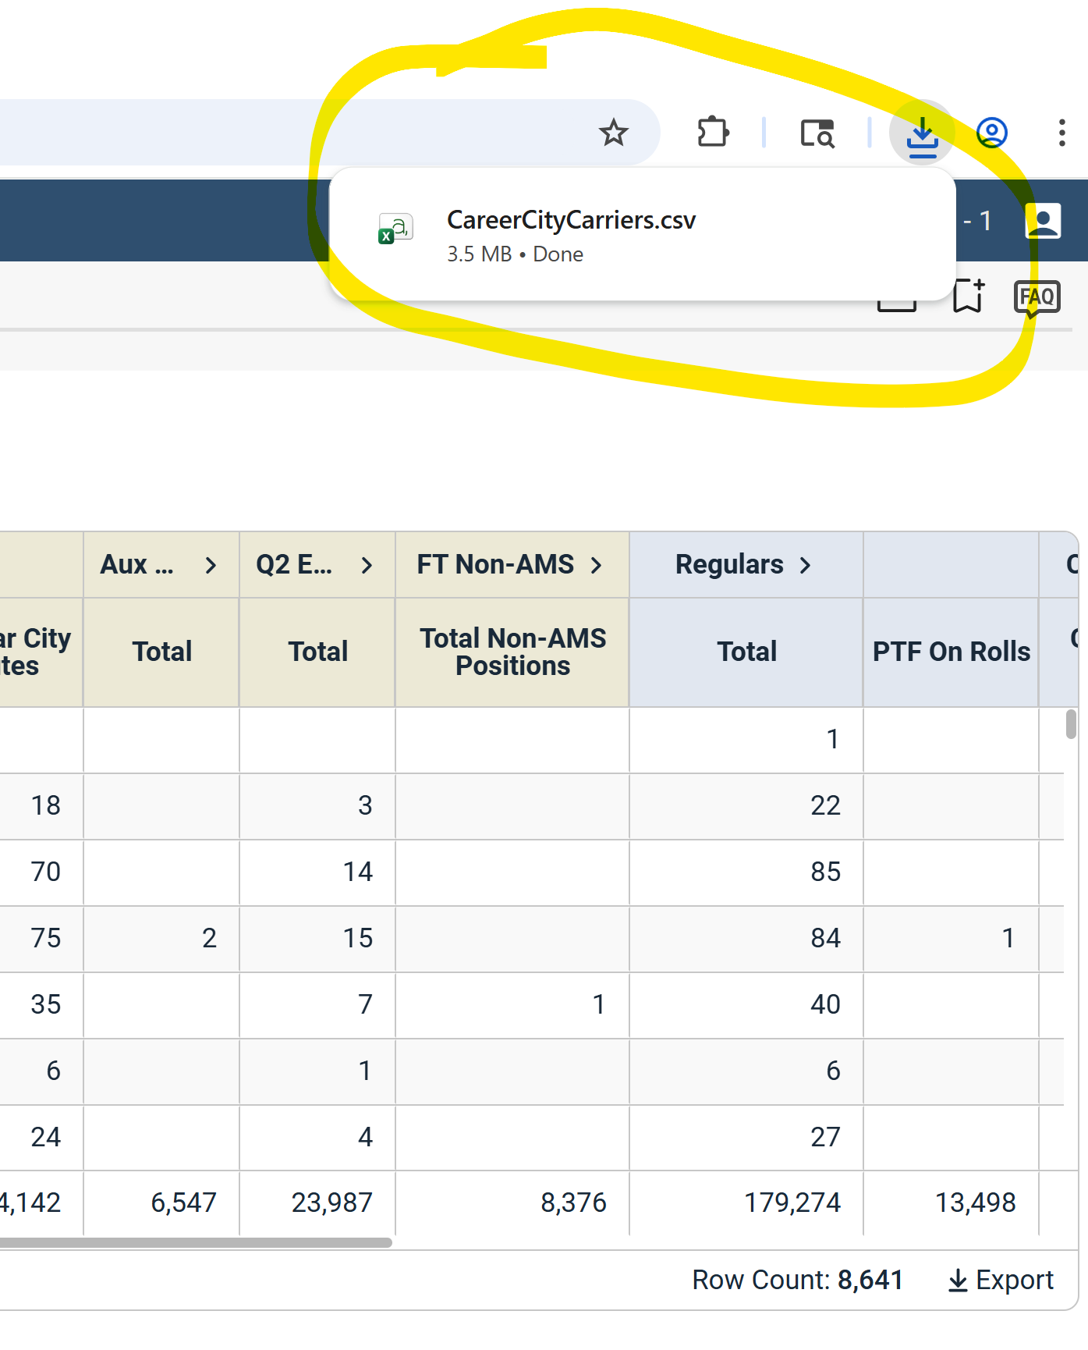
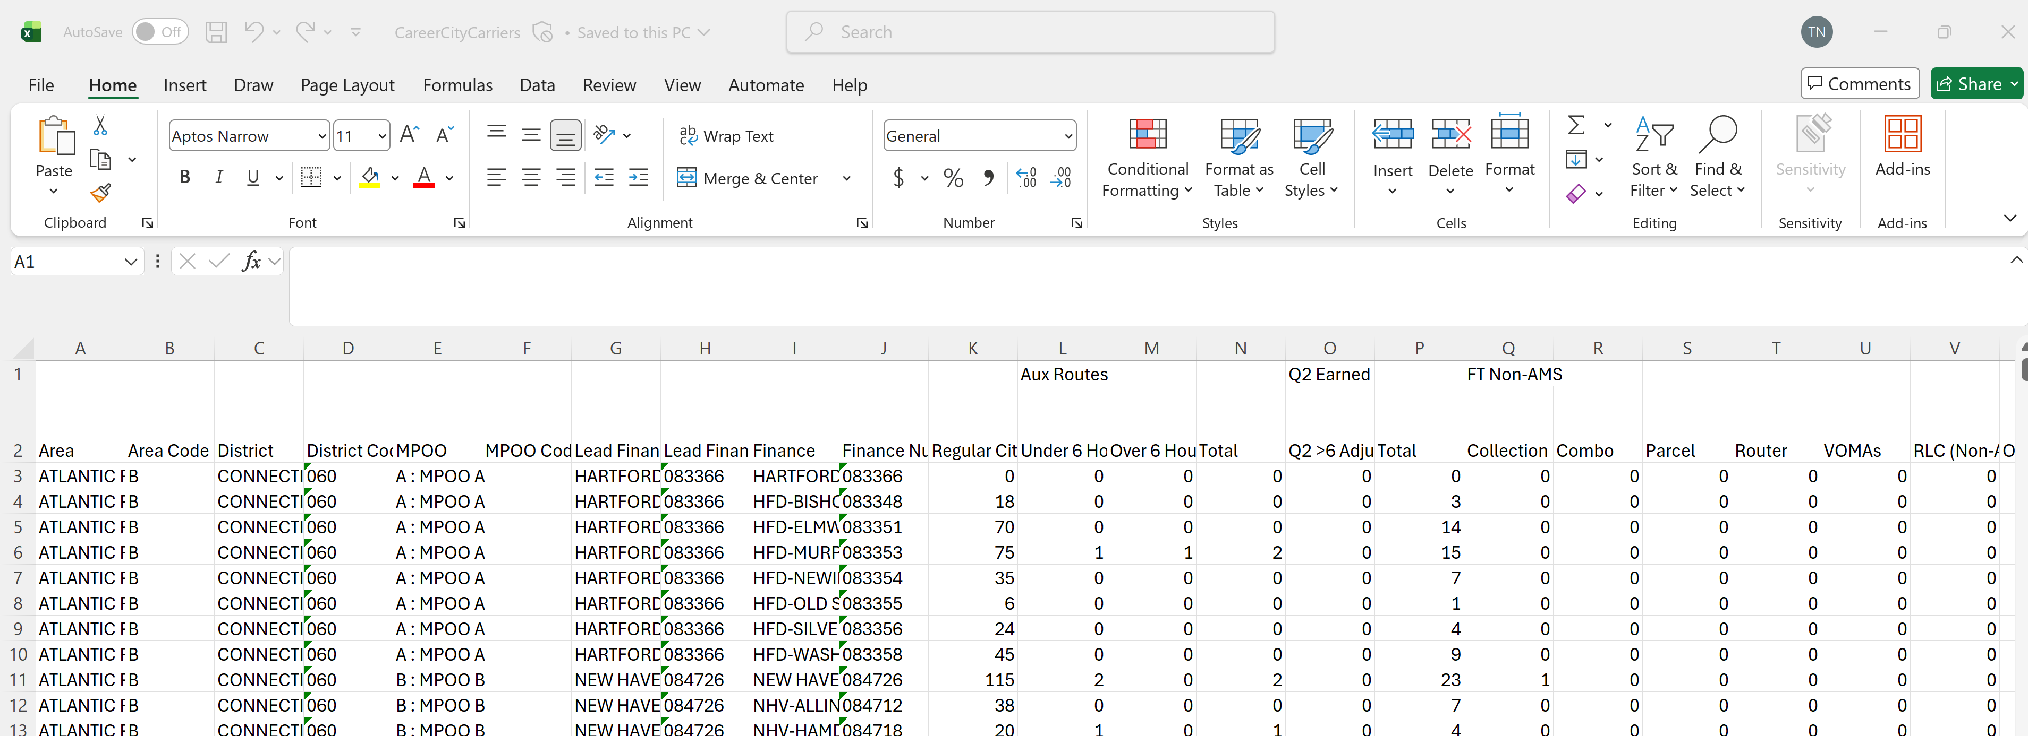

- Then choose Export, Save As, then open in Excel. Don’t worry about leading zeroes being missing, the stored proc handles them.

Open the non_ams_rtes_template.csv file found in the \\eagnmnwbp1665\data\FieldStaffing folder
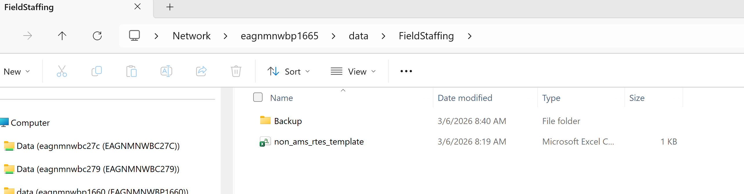

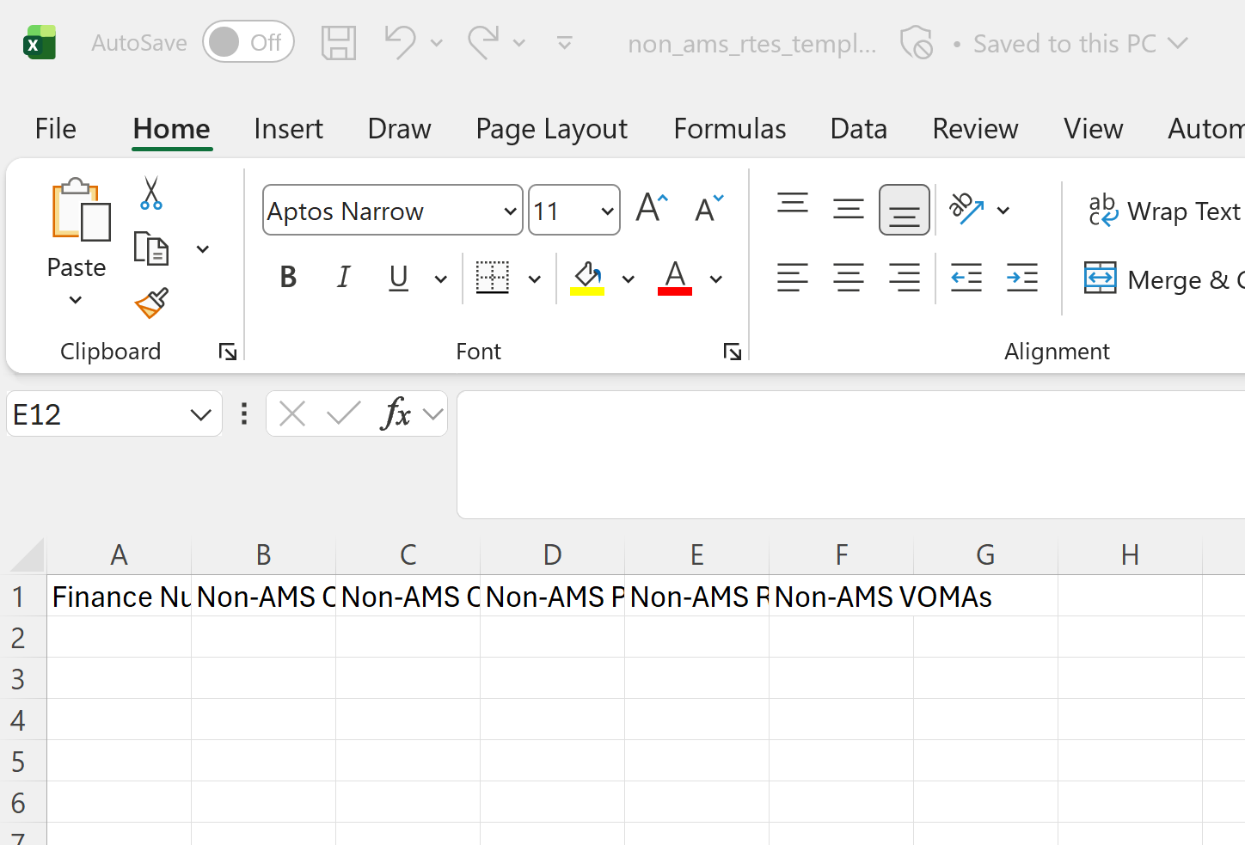

- Copy all the values from the following columns in the workforce dashboard export file into the following columns in the template file (6 columns in total): Only need those selected Columns.
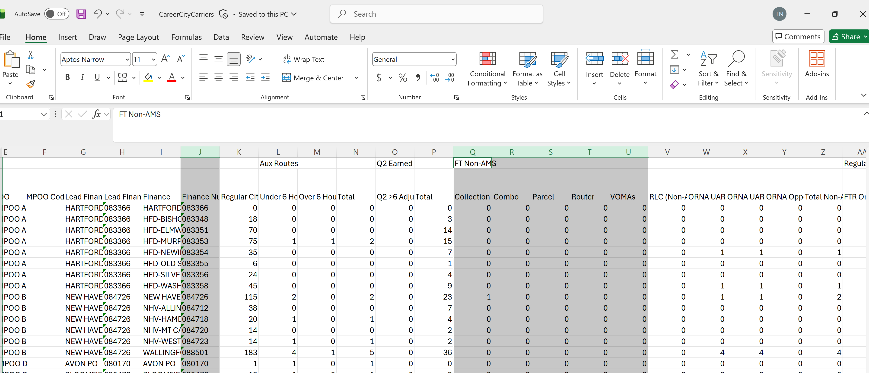
Finance Number,Non-AMS Collection,Non-AMS Combo,Non-AMS Parcel,Non-AMS Router,Non-AMS VOMAs

- Save the updated template file as non_ams_rtes.csv in the FieldStaffing folder

- Run Job NON_AMS_ROUTES in CSV 1241 using GUI:

Htps://wems.usps.gov/ref/home/index.html
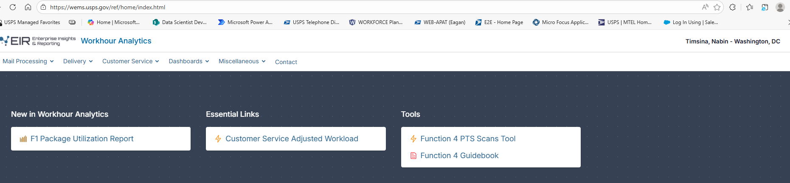

Once you are here, go to Miscellaneous and Click Toolbox. When you click toolbox
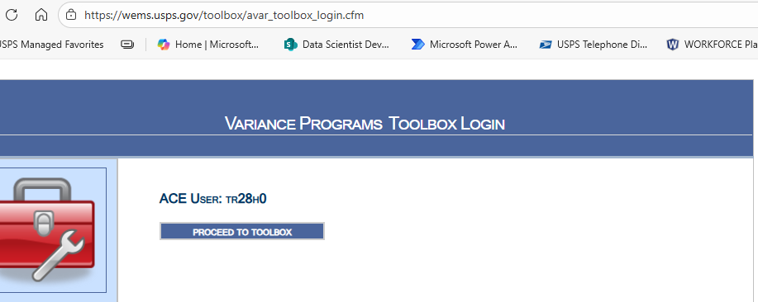
Proceed to ToolBox. After below will appear:
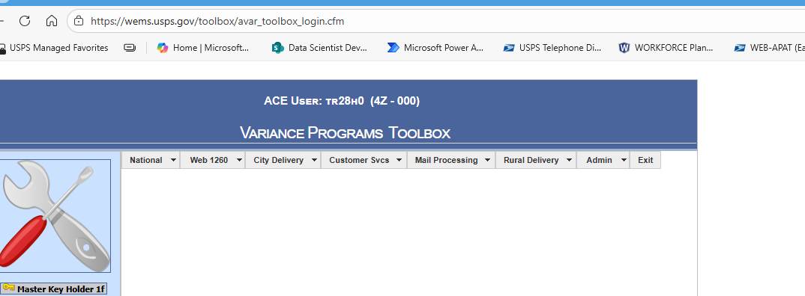

Now Click on Admin on Navigation menu and click DB Admin Console Under admin.

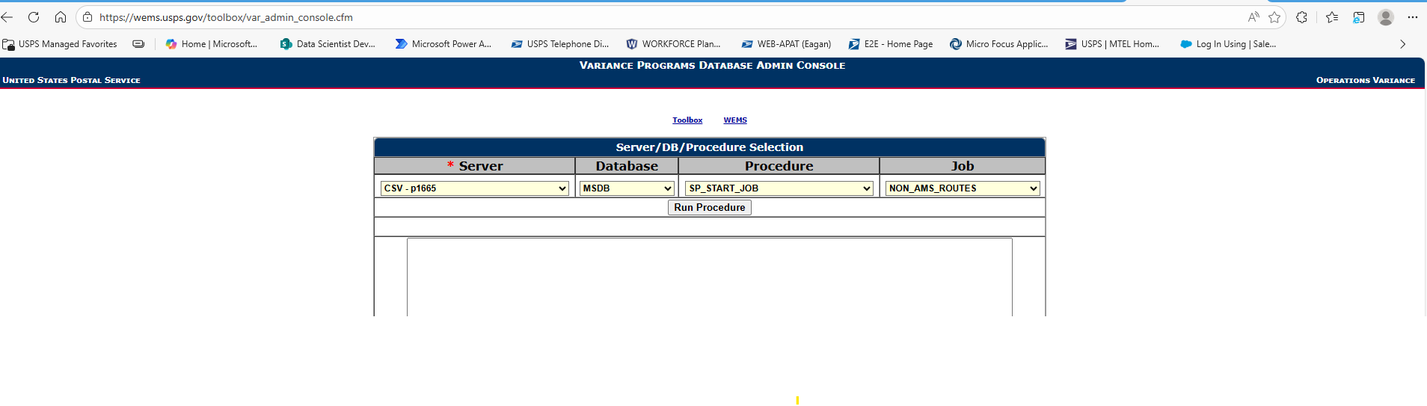

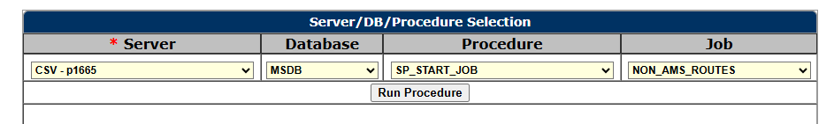
Select as above and hit run Procedure.
Once you do that the File that was placed in FieldStaffing Folder will move to Backup folder inside the same FieldStaffing Folder.
Check that file has been processed and place in FieldStaffing\Backup folder
Done.

